

PANGANI GIRLS’ KCSE PREDICTION
EXAM TEST-2025
312/2
GEOGRAPHY
PAPER 2
TIME: 2¾ HOURS

NAME…………………………………………………………………………………………
SCHOOL………………………………………………. SIGN……………………..
INDEX NO ……………………………………………. DATE…………………….

Kenya Certificate of Secondary Education.

INSTRUCTIONS TO CANDIDATES.
(a)White your name and index number in the spaces provided above.
(b) Sign and write the date of the examination in the spaces provided above.
(c) This paper consists of two sections; A and B.
(d) Answer all the questions in section A and question 6 and any other two questions in section B.
(e) Answer all the questions in English.

SECTION | QUESTIONS | MAXIMUM SCORE | SCORE
A | 1-5 | 25
B | 6 | 25  25  25
 | TOTAL SCORE

SECTION A.
Answer all the questions.
1. a) Give any two ways in which minerals occur. (2 marks)
b) State three problems facing soda ash exploitation in Magadi. (3 marks)
2. a) Define the term agroforestry. (2 marks)
b) State three reasons why agroforestry is being encouraged in Kenya. (3 marks)
3.a) Apart from land pollution name two other types of environmental hazards (2mks)
b) State three ways through which land pollution can be controlled. (3mks)
4.(a) Apart from a telephone, state two other forms of communication (2mks)
(b) Mention three problems facing railway transport in Africa (3mks)
5. a) Apart from the common market for Eastern and southern Africa (COMESA) identify two other trading blocks in Africa. (2mks)
b) Give three benefits of COMESA to member states. (3mks)
SECTION B.
Answer question 6 compulsory and only other two questions from the remaining questions.
6.Study the photograph below and answer questions that follow
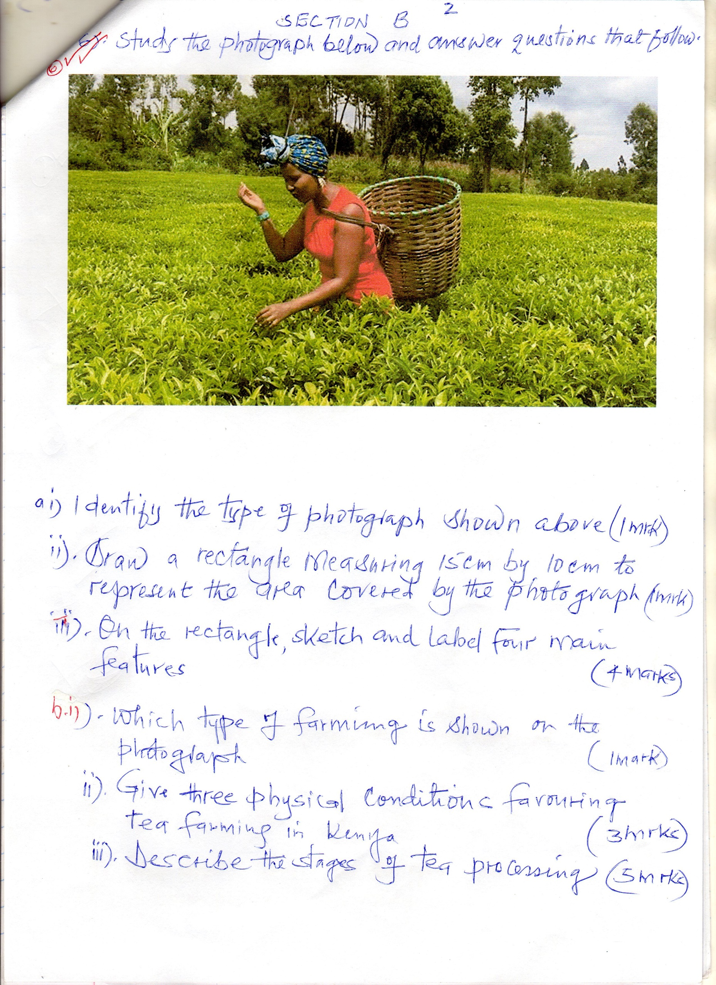
- (i) Identify the type of photograph shown above (1mk)
(ii) Draw a rectangle measuring 15cm by 10cm to represent the area covered by the photograph (i) Identify the type of photograph shown above (1mk)
(ii) Draw a rectangle measuring 15cm by 10cm to represent the area covered by the photograph (1mk)
(iii) On the rectangle, sketch and label four main features (4mks)
- (i) Which type of farming is shown on the photograph (1mk)
(ii) Give three physical conditions favouring tea farming in Kenya (3mks)
(iii) Describe the stages of tea processing (5mks)
- (i) State two areas in Kenya where maize is grown on large – scale (2mks)
(ii) Explain four problems facing maize farmers in Kenya (8mks)

7.a) i) Identify two types of open cast mining . (2mks)
ii) Describe the stages involved in deep- shaft mining (6mks)
b)State three negative effects of mining on the environment (3mks)
c) Give two reasons why Kenya import her oil in crude form (2mks)
d) Explain four ways in which mining contribute to the to the economy of Kenya (8mks)
e) Explain how the following factors influence exploitations of minerals (2mks)
i)) Technology
ii) Quality of the one

8. a) Define the term global warming. (2 marks)
b) Distinguish between environmental conservation and environment management. (2 marks)
c) State four reasons why Kenya should conserve her environment. (4 marks
d) Explain four effects of land pollution to the environment. (8 marks)
e) Briefly explain the main reasons for the following environmental acts in the law of Kenya.
i) The factories act (2 marks)
ii) The water act (2 marks)
f) Your class intends to carry out a field study on environmental water pollution in the locality.
i) State one possible objective for the study. (1 mark)
ii) Give two reasons why you need to conduct a reconnaissance. (2 marks)
iii) Suggest any two ways to control the environmental problem under study. (2 marks)

9.
a) i) Differentiate between population and demography (2mks)
ii) State two types of migration (2mks)
iii) State three causes of rural- rural migration (3mks)
b) Explain how the following factors led to the population increase in Kenya
- Migration (2mks)
- Improved medical care (2mks)
- Cultural beliefs and traditions (2mks)
c) Explain three problems which result from high population growth rate in Kenya (6mks)
d) Explain three ways in which the population of Kenya differs from that of Sweden (6mks)

10. Study the world map shown below and answer questions that follow.
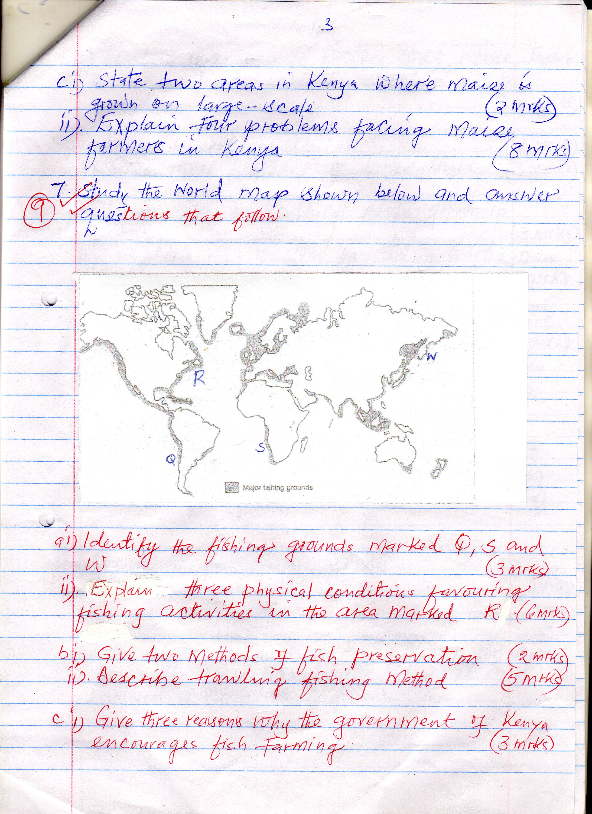
(a) (i) Identify the fishing grounds marked Q, S and W (3mks)
(a) (i) Identify the fishing grounds marked Q, S and W (3mks)
(ii) Explain three physical conditions favouring fishing activities in the area marked R
(6mks)
(b) (i) Give two methods of fish preservation (2mks)
(ii) Describe trawling fishing methods (5mks)
(c) (i) Give three reasons why the government of Kenya encourages fish farming (3mks)
(ii) Explain three human factors that make Japan to be a leading fishing nation in the world (6mks)

